LAB 1 Working With Regular Files

1.
#include <stdio.h>
#include <stdlib.h>
#include <sys/stat.h>
#include <fcntl.h>
#include <string.h>
#include <unistd.h>
#define SZ 500

int main(int argc, char const *argv[])
{
char c,line[SZ];
int i=0;
int fd = open(argv[2],O_RDONLY);
while(read(fd,&c,1)==1){
if(c=='\n'){
if(strstr(line,argv[1])!=NULL){
line[i++]='\n';
line[i]='\0';
write(1,line,i);

}
i=0;

}
else{
line[i++]=c;
line[i]='\0';
}
}
close(fd);
return 0;
}
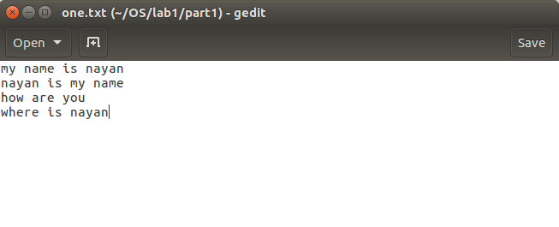

Input file:
Output:
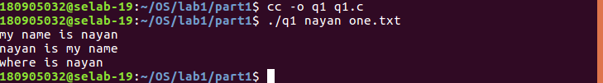
2.
#include <stdio.h>
#include <stdlib.h>
#include <sys/stat.h>
#include <fcntl.h>
#include <string.h>
#include <unistd.h>
#define SZ 500

int main(int argc, char const *argv[])
{
char c;
int i,j=0;
for(i=1;i<argc;i++){
int fd = open(argv[i],O_RDONLY);
//j=0;
while(read(fd,&c,1)==1){
if(c=='\n'){
j++;
//printf("\n");

if(j!=0&&j%20==0){
fgetc(stdin);

}

}

write(1,&c,1);

}
printf("*********************************\n");
close(fd);
}
return 0;
}

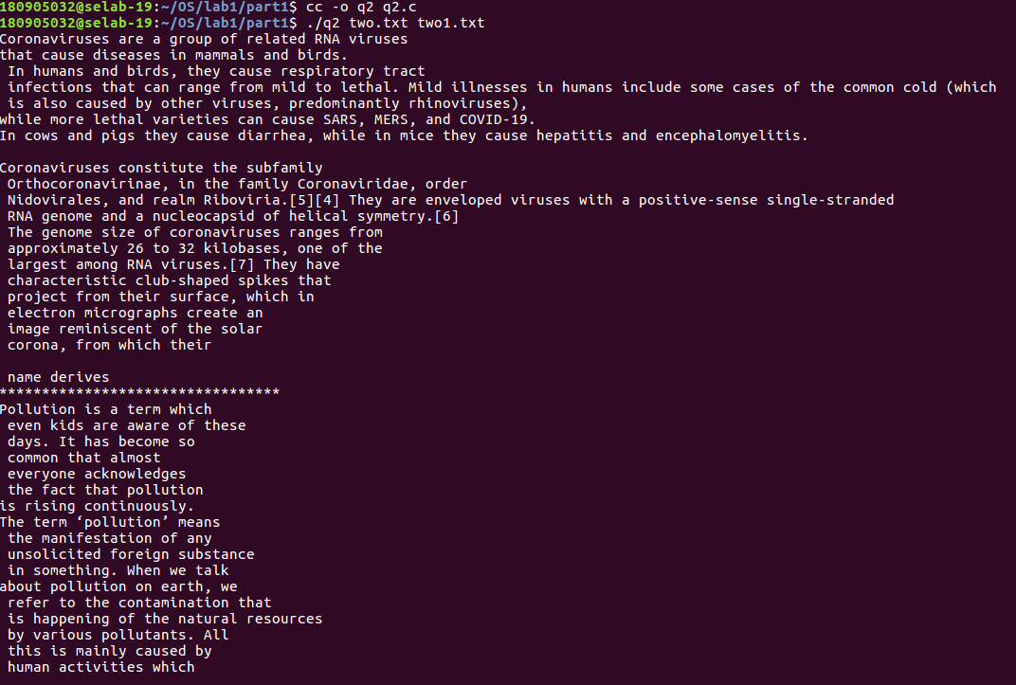
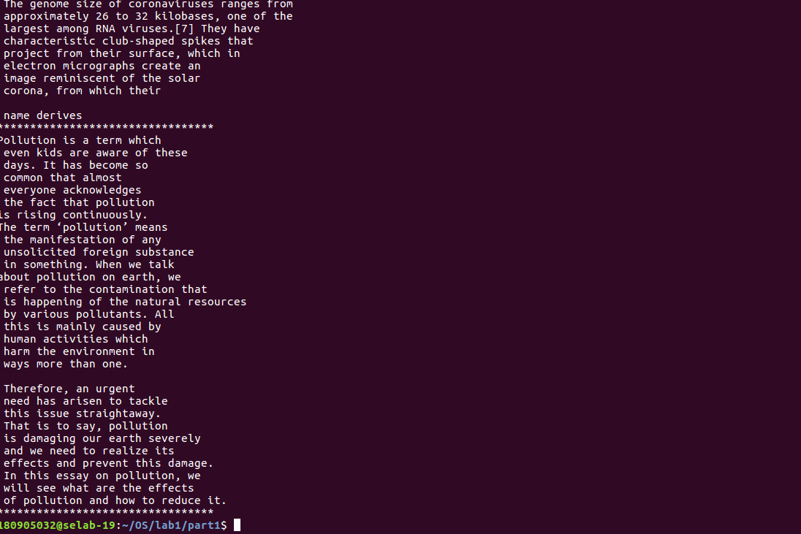
3.
#include <stdio.h>
#include <stdlib.h>
#include <unistd.h>
int main(int argc, char const *argv[])
{
int a=20;
float f=100.0;
char c='#';

printf("%d\n",c);
printf("%x\n",a);
printf("%lf\n",f);
printf("%c\n",c);
printf("%e\n",f);
return 0;
}

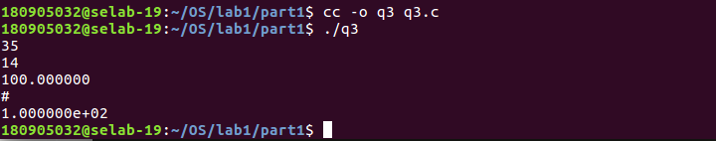
4.
#include <stdio.h>

int main(int argc, char const *argv[])
{
FILE *fa,*fb;
char c;
fa = fopen(argv[1],"r");
fb = fopen(argv[2],"w+");
c = fgetc(fa);
while(c!=EOF){
fputc(c,fb);
c=fgetc(fa);
}
fclose(fa);
fclose(fb);
return 0;
}

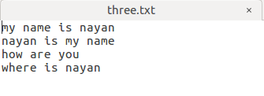

Sample Program:
#include <unistd.h>
#include <stdlib.h>
#include <fcntl.h>
#include <sys/stat.h>
#include <string.h>
int main(int argc, char const *argv[])
{
//write
if((write(1,"Here is some data\n",18))!=18)
write(2,"A write error has occured on file descriptor 1\n",46);

//read
char buf[128];
int nread;
nread=read(0,buf,128);
if(nread==-1)
write(2,"A write error has occured\n",26);
if((write(1,buf,nread))!=nread)
write(2,"A write error has occured on file descriptor 1\n",27);

//copy file
char c;
int in,out;
in = open("in.txt",O_RDONLY);
out = open("out.txt",O_WRONLY|O_CREAT,S_IRUSR|S_IWUSR);
while(read(in,&c,1)==1)
write(out,&c,1);

exit(0);
}
